**Derivative by Power Rule**

**Q1. Write a c++ program to calculate the derivative of any**

**function by power rule.**

**Program:**

**#include <iostream>**

**#include<conio.h>**

**using namespace std;**

**int main()**

**{**

**int value;**

**cout<< "\n\n\tDERIVATIVES By Power rule";**

**cout<<"\n\nHow many value you want to enter in Derivative Function? : ";**

**cin>>value;**

**int coef[value],exp[value];**

**for(int i=0;i<value;i++)**

**{**

**cout << "\n\nEnter coefficient of "<<i+1<<" value : ";**

**cin >> coef[i];**

**cout << "Enter exponent of "<<i+1<<" value: ";**

**cin >> exp[i];**

**}**

**cout<<"\n\nf(x) = ";**

**for(int i=0;i<value;i++)**

**{**

**cout<<coef[i]<<"x^"<<exp[i];**

**if(i!=value-1)**

**cout<<"+";**

**}**

**int product;**

**cout<<"\n\nf'(x) = ";**

**for(int i=0;i<value;i++)**

**{**

**product=coef[i]*exp[i];**

**if(product!=0)**

**{**

**if(exp[i]-1==0)**

**cout<<product;**

**else**

**cout<<product<<"x^"<<exp[i]-1;**

**}**

**else**

**cout<<0;**

**if(i!=(value-1))**

**cout<<" + ";**

**}**

**getch();**

**return 0;**

**}**

**Output console 1:**

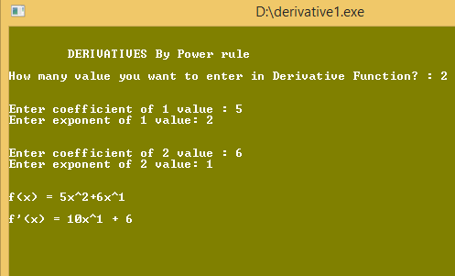

**Output console 3:**

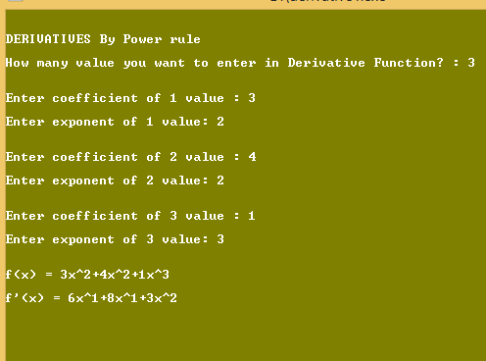

**Output console 2:**

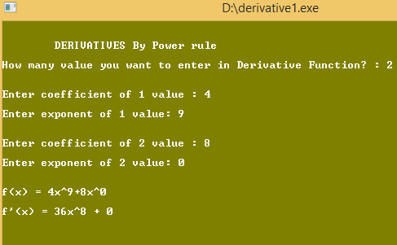

**Output console 4:**

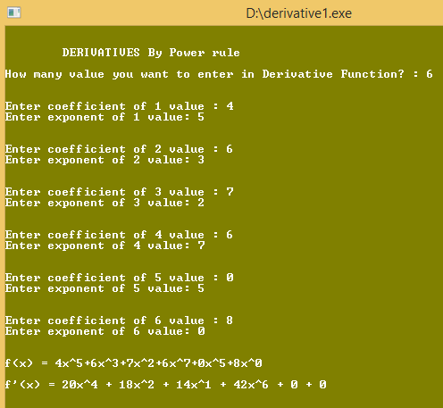

**Integration by parts**

**Q2. Write a c++ program to integrate any function by using**

**integration by parts.**

**Program:**

**#include<iostream>**

**#include<conio.h>**

**using namespace std;**

**int main()**

**{**

**cout<<"\n\tIntigration By Parts";**

**cout<<endl<<"\nIntegration of x^2 * e^x";**

**int cofi,exp;**

**cofi=1;**

**exp=2;**

**cout<<endl<<endl;**

**cout<<"Solution: ";**

**cout<<endl<<endl;**

**for(int i=1;i<=5;i++)**

**{**

**cout<<"\t="<<" x^"<<exp<<"*e^x - ";**

**if(i==1)**

**cout<<"integral [ "<<"e^x * "<<cofi<<"x^"<<exp<<"]";**

**else if(i==2)**

**cout<<"integral [ "<<"e^x * "<<cofi*exp<<"x^"<<exp-1<<"]";**

**else if(i==3)**

**cout<<cofi*exp<<"integral [ "<<"e^x * "<<"x^"<<exp-1<<"]";**

**else if(i==4)**

**cout<<cofi*exp<<"x*"<<"e^x +"<<cofi*exp<<" integral ["<<"e^x"<<"]";**

**else if(i==5)**

**cout<<cofi*exp<<"x*"<<"e^x + "<<cofi*exp<<"e^x";**

**if(i!=5)**

**cout<<endl<<endl;**

**}**

**cout<<" + C ";**

**getch();**

**return 0;**

**}**

**Output console:**

